**Assignment 4**

* **Queries**

**1)**

**Procedure to find average freight: -**

CREATE PROCEDURE usp_GetAverageCustomerFreight(

@customer_id char(5),

@average_freight real = 0 output

)

AS

BEGIN

SELECT @average_freight = AVG(freight)

FROM Customers c

JOIN Orders o ON c.customer_id = o.customer_id

WHERE c.customer_id = @customer_id

END

**Insert trigger to add business rule: -**

CREATE OR ALTER TRIGGER tr_Orders_InsteadOfInsert

ON Orders

INSTEAD OF INSERT

AS

BEGIN

DECLARE @freight real

DECLARE @customer_id char(5)

DECLARE @order_id smallint

SELECT @customer_id = customer_id, @freight = freight, @order_id = order_id

FROM inserted

IF NOT EXISTS(SELECT customer_id FROM Customers WHERE customer_id = @customer_id)

BEGIN

RAISERROR('Customer id does not exists...', 16, 1)

RETURN

END

DECLARE @average_freight real

EXECUTE usp_GetAverageCustomerFreight @customer_id, @average_freight out

PRINT(N'Average freight is ' + CAST(@average_freight as varchar(20)))

IF(@average_freight < @freight)

BEGIN

RAISERROR(N'Freight value is exceeding average freight value for customer id "%s"', 16, 1, @customer_id)

RETURN

END

INSERT INTO Orders

SELECT * FROM inserted

PRINT('Record inserted successfully...!')

END

**Before inserting: -**

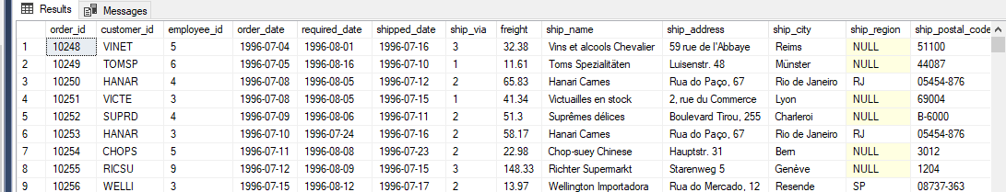

**After insert query: -**

INSERT INTO Orders(order_id, customer_id, employee_id, freight, ship_city) VALUES(10100, 'ALFKI', 1, 20, 'Mumbai')

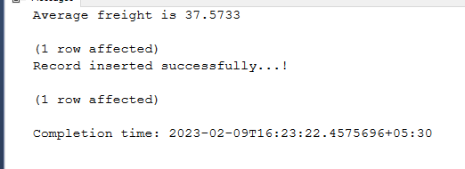

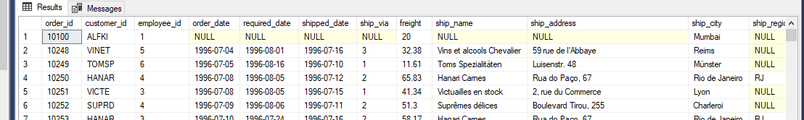

**For high freight value: -**

INSERT INTO Orders(order_id, customer_id, employee_id, freight, ship_city) VALUES(10100, 'ALFKI', 1, 200, 'Mumbai')

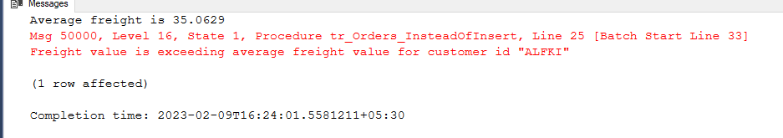

**For invalid customer id: -**

INSERT INTO Orders(order_id, customer_id, employee_id, freight, ship_city) VALUES(10101, 'AABCD', 1, 200, 'Mumbai')

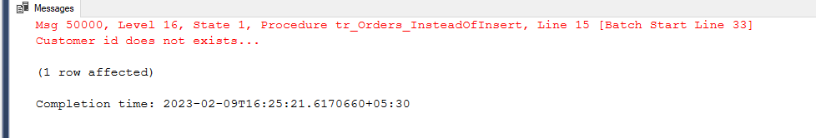

**Update trigger for business rule: -**

CREATE OR ALTER TRIGGER tr_Orders_InsteadOfUpdate

ON Orders

INSTEAD OF UPDATE

AS

BEGIN

DECLARE @freight real = 0

DECLARE @customer_id char(5)

DECLARE @order_id smallint;

SELECT @customer_id = customer_id, @freight = freight, @order_id = order_id

FROM inserted

IF NOT EXISTS(SELECT order_id FROM Orders WHERE order_id = @order_id)

BEGIN

RAISERROR(N'Order id does not exists...', 16, 1)

RETURN

END

DECLARE @average_freight real

EXECUTE usp_GetAverageCustomerFreight @customer_id, @average_freight out

PRINT(N'Average freight is ' + CAST(@average_freight as varchar(20)))

IF(@average_freight < @freight)

BEGIN

RAISERROR(N'Freight value is exceeding average freight value for customer id "%s"', 16, 1, @customer_id)

RETURN

END

DECLARE @employee_id smallint, @order_date date, @required_date date, @shipped_date date, @ship_via smallint,

@ship_name varchar(40), @ship_address varchar(60), @ship_city varchar(15),

@ship_region varchar(15), @ship_postal_code varchar(10), @ship_country varchar(15);

SELECT @order_id = i.order_id,

@customer_id = i.customer_id,

@employee_id = i.employee_id,

@order_date = i.order_date,

@required_date = i.required_date,

@shipped_date = i.shipped_date,

@ship_via = i.ship_via,

@freight = i.freight,

@ship_name = i.ship_name,

@ship_address = i.ship_address,

@ship_city = i.ship_city,

@ship_region = i.ship_region,

@ship_postal_code = i.ship_postal_code,

@ship_country = i.ship_country

FROM inserted i

UPDATE Orders

SET customer_id = @customer_id,

employee_id = @employee_id,

order_date = @order_date,

required_date = @required_date,

shipped_date = @shipped_date,

ship_via = @ship_via,

freight = @freight,

ship_name = @ship_name,

ship_address = @ship_address,

ship_city = @ship_city,

ship_region = @ship_region,

ship_postal_code = @ship_postal_code,

ship_country = @ship_country

WHERE order_id = @order_id

PRINT('Record updated successfully...!')

END

**Before updating: -**

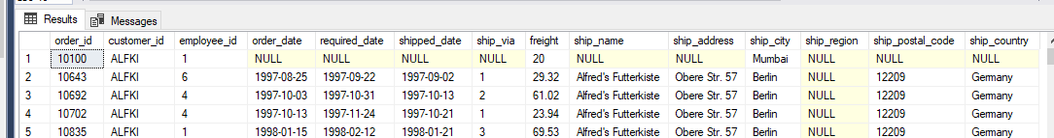

**After update query: -**

UPDATE Orders SET freight = 29.32 where order_id = 10100

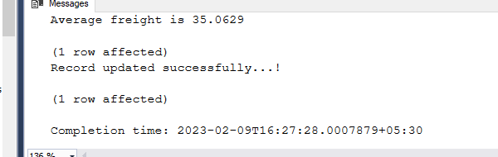

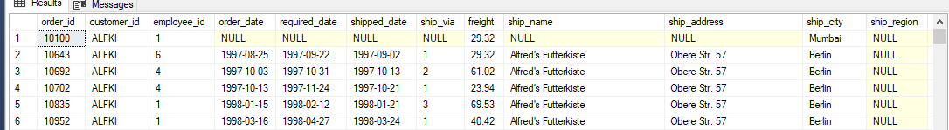

**For high freight value: -**

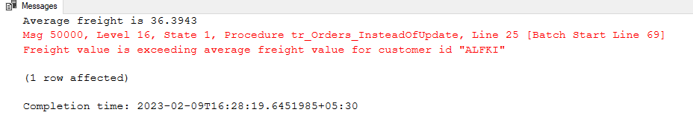

**For invalid order id: -**

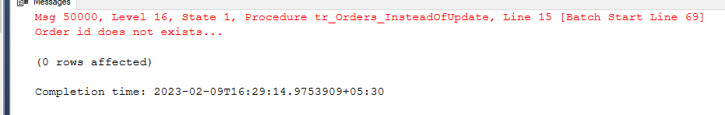

**2)**

CREATE PROCEDURE usp_GetEmployeesSalesByCountry

AS

BEGIN

SELECT e.employee_id AS 'ID',

e.first_name + ' ' + e.last_name AS 'Employee Name',

o.ship_country AS 'Country',

ROUND(SUM(od.unit_price * od.quantity - (od.unit_price * od.quantity * od.discount)), 2) AS 'Total Sale'

FROM Employees e

JOIN Orders o ON e.employee_id = o.employee_id

JOIN OrderDetails od ON o.order_id = od.order_id

GROUP BY e.employee_id, e.first_name, e.last_name, o.ship_country

ORDER BY e.employee_id

END

EXECUTE usp_GetEmployeesSalesByCountry

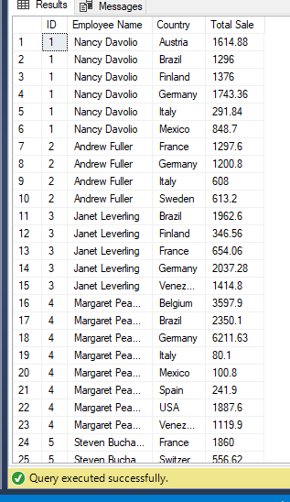

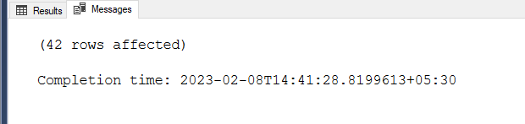

**3)**

CREATE PROCEDURE usp_GetSalesByYear

AS

BEGIN

SELECT DATENAME(Year, o.shipped_date) AS 'Year',

ROUND(SUM(od.unit_price * od.quantity - (od.unit_price * od.quantity * od.discount)), 2) AS 'Total Sale'

FROM Orders o

JOIN OrderDetails od ON o.order_id = od.order_id AND o.shipped_date IS NOT NULL

GROUP BY DATENAME(Year, o.shipped_date)

ORDER BY DATENAME(Year, o.shipped_date)

END

EXECUTE usp_GetSalesByYear

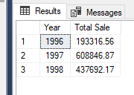

**4)**

CREATE PROCEDURE usp_GetSalesByCategory

AS

BEGIN

SELECT c.CategoryID, c.CategoryName,

ROUND(SUM(od.unit_price * od.quantity - (od.unit_price * od.quantity * od.discount)), 2) AS 'Total Sale'

FROM Categories c

JOIN Products p ON P.CategoryID = c.CategoryID

JOIN OrderDetails od ON od.product_id = p.ProductID

GROUP BY c.CategoryID, c.CategoryName

ORDER BY c.CategoryName

END

EXECUTE usp_GetSalesByCategory

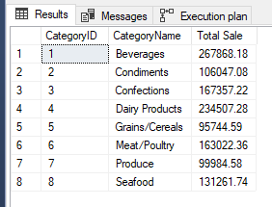

**5)**

CREATE PROCEDURE usp_Get10MostExpensiveProducts

AS

BEGIN

SELECT TOP 10 ProductName, UnitPrice

FROM Products

ORDER BY UnitPrice DESC

END

EXECUTE usp_Get10MostExpensiveProducts

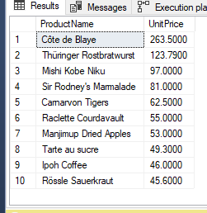

**6)**

CREATE PROCEDURE usp_InsertOrderDetails (

@order_id smallint,

@product_id int,

@unit_price real,

@quantity smallint,

@discount real

)

AS

BEGIN

IF EXISTS (SELECT order_id FROM OrderDetails WHERE order_id = @order_id AND product_id = @product_id)

BEGIN

RAISERROR (N'Record already exist with order id %d and product id %d...!', 11, 1, @order_id, @product_id)

RETURN

END

IF NOT EXISTS (SELECT order_id FROM Orders WHERE order_id = @order_id)

BEGIN

RAISERROR (N'Record does not exist with order id %d...!', 11, 2, @order_id)

RETURN

END

IF NOT EXISTS (SELECT ProductID FROM Products WHERE ProductID = @product_id)

BEGIN

RAISERROR (N'Record does not exist with product id %d...!', 11, 3, @product_id)

RETURN

END

INSERT INTO OrderDetails VALUES (@order_id, @product_id, @unit_price, @quantity, @discount)

PRINT('Record inserted successfully!')

END

EXECUTE usp_InsertOrderDetails 10248, 13, 14, 12, 0

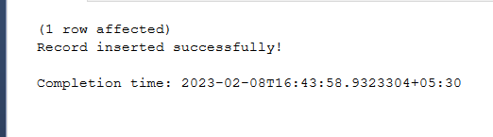 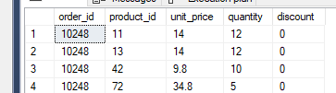

**Validations:-**

**If entry already exists in order details table**



**If order id doesn’t exist in order table**



**If product id doesn’t exist in product table**



**7)**

CREATE PROCEDURE usp_UpdateOrderDetails (

@order_id smallint,

@product_id int,

@column_name varchar(20),

@new_value real

)

AS

BEGIN

IF NOT EXISTS (SELECT order_id FROM OrderDetails WHERE order_id = @order_id AND product_id = @product_id)

BEGIN

RAISERROR (N'Record does not exist having order id %d or product id %d...!', 11, 1, @order_id, @product_id)

RETURN

END

DECLARE @query nvarchar(1000)

SET @query = 'UPDATE OrderDetails

SET ' + quotename(@column_name) + ' = ' + cast(@new_value as varchar(20)) +

' WHERE order_id = ' + cast(@order_id as varchar(20)) + ' AND product_id = ' + cast(@product_id as varchar(20))

PRINT(@QUERY)

EXEC sp_executesql @query;

PRINT('Record updated successfully!')

END

EXECUTE usp_UpdateOrderDetails 10248, 13, 'discount', 0.10

**Before executing query:-**

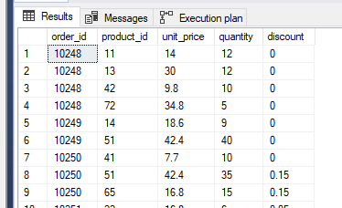

**After running query:-**

